Chemistry 12

Oxidation - Reduction

I) Oxidation and Reduction
What is a redox reaction?

What is oxidation?

What types of elements tend to oxidize?

What is reduction?

What is a good way to remember oxidation and reduction?

In order for a redox reaction to occur, there must be an oxidation AND a reduction (ie. one substance has to first ‘give-up’ electrons in order for another substance to gain them).
Single replacement reactions are redox reactions. Take, for example, the reaction of copper metal in silver nitrate solution:

Cu_{(s)} + AgNO_{3(aq)} ⇒

Copper starts as a metal (in atomic form – neutral) and becomes an ion dissolved in solution with a charge of ______. Were copper donate or receive electrons? ___________________ How many? _________
Therefore, Cu underwent ___________________ and the half-reaction is:

Silver, as a reactant, is a dissolved ion with a charge of _____:
What is silver as a product? ________________________________________
Did silver donate or accept electrons? ________________________
Therefore, _______ underwent _________________, and the half-reaction is:

Nitrate, NO₃⁻, started as a dissolved ion and didn’t change, so it didn’t take part in the redox reaction (it was a spectator ion).

Overall Reaction: Cu_{(s)} + 2AgNO_{3(aq)} 2Ag_{(s)} + Cu(NO₃)_{2(aq)}

Oxidation Half-Reaction:

Reduction Half-Reaction:

Balancing electrons:

Overall NET Redox Reaction:

For every copper atom that oxidized, two electrons were released, which are enough to ______________________________________________________ (hence the 2:1 stoichiometry).

Notice that the reactant that was in metal form, copper, oxidized to become a cation, Cu²⁺, as metals tend to do. Ag⁺, a metal cation, reduced to become a metal (the opposite process - a reduction).
http://www.chem.iastate.edu/group/Greenbowe/sections/projectfolder/flashfiles/redox/home.html click on ‘molecular scale reactions’
A half-reaction specifies the oxidation or reduction that occurred, whereas the net redox reaction is the combination of both and shows what and how the substances changed.

Silverware (silver metal) reacts with H₂S that is present in trace amounts in air to produce Ag₂S (tarnish). The cleaning of silverware is a redox reaction:
2Al + 3Ag₂S ⇒ 6Ag + Al₂S₃
*This reaction requires heat to attain E_{a} and water to act as an electron transfer medium. Thus, the silverware is placed into a pan of water which is lined with aluminum foil and then heated in the oven.

Oxidation half-reaction:

*Remember, oxidation is a loss of electrons, so electrons will be a product
Reduction half-reaction:

*Reduction is a gain of electrons, so electrons will be a reactant
Balance electrons to create the net redox reaction:

Notice that the electrons are not part of the net reaction, as they have been transferred from one substance to the other.

II) Oxidizing Agents and Reducing Agents
An oxidizing agent is a substance that ___________________ another substance. Therefore, the oxidizing agent itself undergoes ______________.
What was the oxidizing agent in the previous example? _________
A reducing agent is a substance that _____________________ another substance. Therefore, the reducing agent itself undergoes ______________.
What was the reducing agent in the previous example? ________

Practice Questions: For each of the following reactants, give the
a) oxidation half-reaction b) reduction half-reaction
c) balanced redox reaction d) oxidizing agent e) reducing agent
1) Zn and Cu²⁺

2) Li and Fe³⁺

3) Br₂ and Cr to produce 2Br⁻ and Cr³⁺

Assignment 1: Read Hebden p.190 (start at ‘Definitions’) & 191 and do
p.192 #1&2

III) Oxidation Numbers
An oxidation number is the real (for atoms, ions, and ionic compounds) or apparent (for covalent compounds) charge that a particle possesses. It is very similar to ‘combining capacity’.
What are oxidation numbers for the ionic compound NaCl?

What are the oxidation numbers for the covalent compound H₂O?

Guidelines for Assigning Oxidation Numbers
When assigning oxidation numbers, the guidelines must be followed IN ORDER.
The sum of the positive and negative charges must equal the overall charge of the substance.
A) For neutral ATOMS, the oxidation number is _______.
Examples : Al P₄ N₂ S₈
Oxidation #: ___ ___ ___ ___
B) For ions, the oxidation number equals the charge.
Examples: Mn²⁺ Br⁻ S²⁻ Cu⁺ Al³⁺
oxidation #: ____ ____ ___ _____ ____
C) Polyatomic ions can be assigned a total oxidation number, which would be its ionic charge, or each element in the ion can be assigned its own oxidation number (part D will explain how this is done).
Find the TOTAL oxidation number: SO₄²⁻ OH⁻ PO₄³⁻
___ ___ ___

D) To assign individual elements an oxidation number in a compound or polyatomic ion, perform the following steps in order:
1) alkali metals are ____
2) alkaline earth metals are ____
3) Other metals with only one possible oxidation number (combining capacity)
4) oxygen is _____
5) hydrogen is +1 (unless part of a metal hydride in which case -1)
ex) CaH₂ Ca is +2, so each H is ___.
6) halogens are -1 (but can also be +1, +3, or +5 in certain compounds)
7) Lastly, assign any ‘hard to predict’ atoms that are left over.

*Since oxidation numbers are apparent for atoms in covalent compounds, sometimes an atom may an oxidation number that’s a fraction.

Practice Questions: Determine the oxidation numbers of each element.
a) MnO₄⁻ b) SO₂ c) SO₄²⁻ d) PCl₅ e) Cu₂O f) HBiO₃ g) OCl⁻

h) NH₂OH i) NO₃⁻ j) I₂ k) Cr³⁺ l) Cr m) N₂O₅ n) H₄P₂O₇

How are oxidation numbers helpful?
When an atom undergoes oxidation during a redox reaction, its oxidation number will ________________________ as it changes from reactant to product (it loses electrons, therefore it becomes more positive).

When an atom undergoes reduction during a redox reaction, its oxidation number will ________________________ as it changes from a reactant to product (it gain electrons, therefore it becomes more negative).

Assigning oxidation numbers to reactants and products in a chemical reaction is helpful in determining whether the reaction is, in fact, a redox reaction, and if so, which reactant is oxidizing and which reactant is reducing.

Practice Questions
1. For the following half-reaction (with electrons not present), how does the oxidation number of chromium change? Is the chromium oxidizing or reducing? Cr₂O₇²⁻ + 14H⁺ ⇒ 2Cr³⁺ + 7H₂O

2. What happens to the oxidation # for nitrogen in the unbalanced half-reaction? Is nitrogen oxidizing or reducing?
NO₂ ⇒ N₂O₃

3. Use oxidation numbers to identify which substance is oxidized and which is reduced in the following redox reactions.
a) 3Cu + 2NO₃⁻ + 8H⁺ ⇒ 3Cu²⁺ + 2NO + 4H₂O

b) I₂ + 5HOBr + H₂O ⇒ 2IO₃⁻ + 5Br⁻ + 7H⁺

4. Use oxidation numbers to determine whether the following reactions are redox reactions.
a) 2H₂O ⇒ 2H₂ + O₂

b) 2AgCl + BaSO₄ ⇒ Ag₂SO₄ + BaCl₂

Assignment 2:
Read Hebden p.193-194,
1) Do Hebden p. 194 #3-6
2) For each unbalanced reaction, what is being oxidized and what is being reduced?
a) S²⁻ + ClO₃⁻ ⇒ Cl⁻ + S
b) Cl₂ + SO₂ ⇒ 2Cl⁻ + SO₄²⁻
c) Mn²⁺ + HBiO₃ ⇒ Bi³⁺ + MnO₄⁻
d) FeS + NO₃⁻ ⇒ NO + SO₄²⁻ + Fe³⁺
3) Consider the following reaction:
Zn_{(s)} + 2H⁺_{(aq)} ⇒ Zn²⁺_{(aq)} + H_{2(g)}
The species being oxidized is: (circle the correct response)
A. H₂ B. H⁺ C. Zn D. Zn²⁺
4) When SO₄²⁻ reacts to form S₂O₆²⁻ , the sulfur atoms
A. lose electrons and are reduced
B. gain electrons and are reduced
C. lose electrons and are oxidized
D. gain electrons and are oxidized
5) In a reaction, the oxidation number of Cr decreases by 3. This indicates that Cr is
A. reduced
B. oxidized
C. neutralized
D. a reducing agent
6) Consider the following redox reaction:
C₂H₅OH + 2Cr₂O₇²⁻ + 16H⁺ ⇒ 2CO₂ + 4Cr³⁺ + 11H₂O
Each carbon atom loses
A. 2 electrons
B. 4 electrons
C. 6 electrons
D. 12 electrons

IV) Table of Standard Reduction Potentials
Go to the last page of the data booklet and investigate the redox table.

What is listed on the left side?
Another description for the substances on the left side are _______________________________________________________________.
They are listed from top (strongest) to bottom (weakest). Notice that when you read the reactions from left to right, each is a reduction.
Notice that many of the strongest oxidizing agents are halogens and oxyanions.

What is on the right side? ____________________________________________
Another description for the substances on the right side are _________________________________________________________________.

These are listed from strongest (BOTTOM) to weakest (TOP), like the bases on the acid-base table.
Notice that the oxidation half-reactions are from right to left on the table, as this shows electon(s) being given away.
What types of substances are the strongest reducing agents?

The double arrow does not mean the reactions are at equilibrium; it means that the half-reactions can occur in either direction depending on the substances present in a reaction. Once you know the direction to use for a specific half-reaction (depending on whether it’s an oxidation or reduction), use only a one-way arrow.

Why do some substances such as Cu⁺, H₂O₂, & Fe²⁺ appear on both sides of the table?

Some metals have more than one common oxidation number, and therefore will have multiple half-reactions on the table (such as iron and copper). Locate all of the copper half-reactions on the table.

Be sure to use the correct half-reaction when dealing with these metals.

Some half-reactions require acidic conditions (meaning H⁺ must be present), and some require basic conditions (meaning OH⁻ must be present).

V) Predicting Spontaneity
How might you know whether a redox reaction is spontaneous (__________________________________________) or not?
Remember, in order for a redox reaction to occur, there must be an oxidation AND a reduction occurring simultaneously.

The first thing to do is figure out what substance is reducing and what substance is oxidizing. Then jot down the half-reactions for each.
1. If the reduction half-reaction is higher on the table than the oxidation half-reaction, the reaction is SPONTANEOUS.
2. If the reduction half-reaction is lower on the table than the oxidation half-reaction (or, if it’s on the same line), the reaction is _______________.
3. No redox reaction can occur if you have substances that only reduce or substances that only oxidize (both on the same side of the table).

Practice Questions:
1. Are the following reactions spontaneous?
a) CuSO₄ + Zn ⇒ Cu + ZnSO₄

b) Zn + Ag₂S ⇒ 2Ag + S²⁻ + Zn²⁺

c) S + NO₃⁻ + 6H⁺ ⇒ NO + H₂S + 2H₂O

2) Which metal can be oxidized by I₂ but not by an acidic solution of SO₄²⁻ ?

3) Which metal an act as a reducing agent for Sn²⁺ but not for Co²⁺

Assignment 3
1) Which of the following reactions occur spontaneously?
a) Cr³⁺ + Ba ⇒ Ba²⁺ + Cr
b) I₂ + 2Cl⁻ ⇒ Cl₂ + 2I⁻
c) 2NO₃⁻ + 8H⁺ + 3Ni ⇒ 2ΝΟ + 4Η₂Ο + 3Νi²⁺
d) 2Al³⁺ + 3Ca²⁺ ⇒ 2Αl + 3Ca
2) What products are formed when NO₃⁻ in acidic solution is reduced by Fe_{(s)}?
3) Read Hebden p.195-199 and do p.199 #8ace, 9ac, 10ac, 11aeg, 12

VI) Redox Logic Problems
Strategy to solve redox logic problems:
- separate all substances into oxidizing agents and reducing agents
- write the reduction half-rxns
- use the given information to order the half-reactions into a mini table
- solve the problem using the mini table
Example: Given the following information:
Z + K⁻ ⇒ Z⁻ + K
K⁻ + M ⇒ no spontaneous reaction
List the reducing agents from strongest to weakest (M is a nonmetal and becomes M⁻ when reduced).

Example: Given the following information:
A⁻ + L⁺ ⇒ no spontaneous reaction
A⁻ + P ⇒ A + P⁻
List the oxidizing agents from strongest to weakest (L is a metal and becomes L⁺ when oxidized).

Assignment 4:
1) Do Hebden p.200 #14-18

Assignment 5: Multiple Choice Review Practice
1. Consider the following oxidation-reduction reaction:
2Mn²⁺ + 2IO₃⁻ + 2H₂O ⇒ 2MnO₄⁻ + I₂ + 4H⁺
The reducing agent is
A. I₂ B. IO₃⁻
C. H₂O D. Mn²⁺
2. Consider the reaction below:
Cu²⁺_{(aq)} + Ni_{(s)} ⇒ Ni²⁺_{(aq)} + Cu_{(s)}
This reaction will proceed spontaneously because Cu²⁺
A. is more easily oxidized than Ni²⁺
B. is a weaker reducing agent than Ni²⁺
C. is a stronger reducing agent than Ni²⁺
D. gains electrons more readily than does Ni²⁺
3. A piece of zinc metal is dropped into a solution of FeCl₂. The result of this procedure is
A. no reaction B. the zinc is oxidized by Cl₂
C. the iron is oxidized by Zn²⁺ D. the zinc is oxidized by Fe²⁺
4. Consider the redox reaction below:
2BrO₃⁻ + 10Cl⁻ + 12H⁺ ⇒ Br₂ + 5Cl₂ + 6H₂O
The oxidation half-reaction involved in this reaction is
A. 2Cl⁻ ⇒ Cl₂ + 2e⁻
B. 2H⁺ ⇒ H₂ + 2e⁻
C. BrO₃⁻ + 6H⁺ + 5e⁻ ⇒ 1/2Br₂ + 3H₂O
D. BrO₃⁻ + 6H⁺ ⇒ 1/2Br₂ + 3H₂O + 5e⁻
5. Oxidation is the process involving a
A. gain of protons B. loss of protons
C. loss of electrons D. gain of electrons
6. In a reaction, the oxidation number of S changes from 6 to 4. This information tells us that sulfur has acted as
A. a reducing agent, losing 2e⁻
B. a reducing agent, gaining 2e⁻
C. an oxidizing agent, losing 2e⁻
D. an oxidizing agent, gaining 2e⁻

7. Consider the reaction: 2H₂O + Al + MnO₄⁻ ⇒ Al(OH)₄⁻ + MnO₂
The substance which undergoes reduction is
A. Al B. H₂O
C. MnO₄⁻ D. Al(OH)₄⁻
8. Consider the reaction: 2H⁺ + 2e⁻ ⇒ H₂
The reaction represents
A. oxidation B. reduction
C. electrolysis D. replacement
9. Which of the following is non-spontaneous?
A. Pb(NO₃)₂ + Ni ⇒ Pb + Ni(NO₃)₂
B. 2AgNO₃ + Ni ⇒ 2Ag + Ni(NO₃)₂
C. Co(NO₃)₂ + Ni ⇒ Co + Ni(NO₃)₂
D. 2Au(NO₃)₃ + 3Ni ⇒ 2Au + 3Ni(NO₃)₂
10. Which one of the following is the strongest reducing agent?
A. Al B. Ag
C. Ag⁺ D. Al³⁺
11. The oxidation number of an element decreases during a reaction. This implies that atoms of that element
A. lost electrons B. were oxidized
C. gained electrons D. acted as a reducing agent
12. Which of the following is the strongest oxidizing agent?
A. Cu²⁺ B. Pb²⁺
C. Ni²⁺ D. Sn²⁺
13. Metallic platinum reacts spontaneously with Au³⁺_{(aq)} but does not react with Ag⁺_{(aq)} . The metals, in order of increasing strength as reducing agents, are
A. Ag, Pt, Au B. Pt, Au, Ag
C. Au, Ag, Pt D. Au, Pt, Ag
14. Which of the following pairs of ions will react spontaneously in solution?
A. Cu²⁺ and Fe²⁺ B. Pb²⁺ and Sn²⁺
C. Co²⁺ and Cr²⁺ D. Mn²⁺ and Cr²⁺
15. When NO₂ reacts to form N₂O₄ the oxidation number of nitrogen
A. increases by 2 B. increases by 4
C. increases by 8 D. does not change

VII) Writing Balanced Equations for Redox Reactions Using the Standard Reduction Table
Steps:
1) Find the appropriate reduction and oxidation half-reactions from the table, and write them down, one above the other.
2) Balance electrons.
3) Cancel where appropriate and write the balanced equation. Electrons should cancel and not be written in the overall redox reaction
(electrons should only be present in half-reactions).

Practice Questions: Write a balanced reaction for the following reactants.
1. MnO₄⁻ (acidic) and H₂SO₃

2. Cu and NO₃⁻ (acidic) to produce Cu²⁺ and NO

Assignment 6: Write a balanced equation for each of the following
a) H₂O₂ (acidic) and N₂O_{4(aq)}
b) Ag⁺ and H₂S_{(g)}
c) IO₃⁻ (acidic) and H₂O₂
d) H₃PO₄ (acidic) and NO

VIII) Balancing Half-Reactions Without the Use of the Reduction Table
Using the following guidelines, it is possible to build and balance half-reactions that are not on the redox table starting only with a skeleton half-reaction.
Guidelines: ‘MAJOR HYDROXIDE’ (MAJOR OH⁻)
1. MAJOR: Balance all major elements (all elements except O and H).
2. ‘O’: Balance oxygen by adding H₂O molecules to the applicable side.
3. ‘H’: Balance hydrogen by adding H⁺ ions to the applicable side.
4. - : Balance the charge by adding electrons to the applicable side.
*5. If necessary: If the half-reaction is basic, you must use the equation
H₂O ⇔ H⁺ + OH⁻ (can also be written the other way around) to cancel protons (which are acidic) from the half-reaction and end up with OH⁻ ions (which are basic).
Practice Questions: (other examples on Hebden p. 201-203):
1) Balance the half-reaction whereby NO is reduced to N₂O in acidic solution. Skeleton half-reaction: NO ⇒ N₂O

2) Balance the half-reaction whereby Mn²⁺ is oxidized to MnO₂ in acidic solution Skeleton half-reaction: Mn²⁺ ⇒ MnO₂

3) Balance the half-reaction whereby HO₂⁻ is oxidized to O₂ in basic solution. Skeleton half-reaction: HO₂⁻ ⇒ O₂
4) Balance the following half-reaction in basic solution.
Skeleton half-reaction: Cu₂O ⇒ Cu(OH)₂

Assignment 7:
1) Do Hebden p. 203 #19a-m

IX) Balancing Full Redox Reactions not on the Redox Data Table
Steps:
1. Figure out which reactant substances match up with which product substances to build skeleton half-reactions. Make sure all ‘major’ elements are present in a half-reaction from the start.
2. Balance each half-reaction using MAJOR OH⁻ guidelines. However, do not convert to basic (if asked) until after step 4 of this list.
3. Write newly constructed half-reactions one on top of the other and balance electrons.
4. Put half-reactions together and cancel where necessary (electrons should always cancel out).
*5. If necessary: Convert to basic conditions in same manner as previously. If there are no H⁺ ions left to convert to basic, then no conversion is possible or necessary.
Practice Questions: Balance each of the following redox reactions
1) H₂PO₂⁻ + CNO⁻ ⇒ CN⁻ + HPO₃⁻ (acidic)

Disproportionation Reaction: a redox reaction in which the same substance is both reduced AND oxidized to make two different products.
2) Balance the following disproportionation reaction under basic conditions:
P₄ ⇒ H₂PO₂⁻ + PH₃

3) H₂O₂ + SCN⁻ ⇒ ΝΗ₄⁺ + Η₂Ο + ΗCO₃⁻ + HSO₄⁻ (acidic)

Assignment 8:
1) Hebden p. 207 #24a,d,i,j,q,w
X) Redox Titrations
Similar to acid-base titrations, redox titrations are also useful for determining the unknown concentration of a solution. However, the titration reaction is a redox reaction rather than an acid-base reaction.
A common solution used for titrations is acidified aqueous potassium permanganate, KMnO_{4(aq)} (actually K⁺_{(aq)} and MnO₄⁻_{(aq)}), because permanganate (MnO₄⁻) is a strong oxidizing agent (top left of table) when in the presence of anacid, and there is a built in colour change as MnO₄⁻ is purple and reacts to become colourless Mn²⁺_{(aq)}:
MnO₄⁻ + 8H⁺ + 5e⁻ ⇒ Mn²⁺ + 4H₂O
purple colourless
Purple MnO₄⁻ solution (from the buret) will spontaneously oxidize most reducing agents of unknown concentration (in the flask). How do you know this?

As purple MnO₄⁻ ions drop into the flask, they will react with the reducing agent to produce Mn²⁺ ions, so the mixture in the flask will remain colourless. Once all of the reducing agent from the flask has reacted with MnO₄⁻, the equivalence point has been reached, so the next drop of MnO₄⁻ solution added will …

Practice Question: When 25.00mL of Cr³⁺ solution is titrated with 0.300M KMnO₄ solution, the titration takes 28.32mL of KMnO₄ solution to reach the endpoint according to the following equation:
6MnO₄⁻ + 10Cr³⁺ + 11H₂O ⇒ 6Mn²⁺ + 5Cr₂O₇²⁻ + 22H⁺
Calculate the original [Cr³⁺].

The dichromate ion (Cr₂O₇²⁻), which creates an orange solution, can be used as an oxidizing agent for many redox titrations if in an acidic environment, as it’s high on the left side of the table, and it reacts to produce the Cr³⁺ ion, which forms a green solution.
Assignment 9: 1) Do Hebden p. 213-214 #26, 28, 29

XI) The Electrochemical Cell
What is another name for an electrochemical cell?
What is the point of an electrochemical cell?

How does an electrochemical cell work?
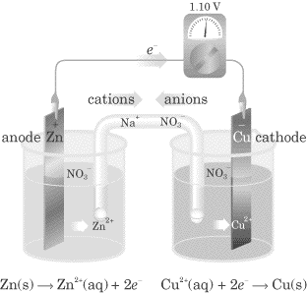

‘AN OX CARED’
Description of the Electrochemical Cell on the Previous Page
Oxidation takes place at the anode, as Zn metal atoms lose two electrons to become Zn²⁺ cations (Zn ⇒ Zn²⁺ + 2e⁻) which then dissolve in the Zn(NO₃)_{2(aq)} solution. The electrons travel up the Zn electrode and through the wire to the cathode Cu electrode where they are used to reduce Cu²⁺ cations to Cu metal atoms (Cu²⁺ + 2e⁻ ⇒ Cu). The electrons travel from the oxidation to the reduction half-cell because they feel the ‘pull’ for electrons from the Cu²⁺ ions (similar to how we feel the ‘pull’ from gravity). The Cu²⁺ ions are attracted to the cathode (Cu metal strip) by the electrons that are arriving through the wire. The anode Zn electrode loses mass (as Zn atoms make Zn²⁺ ions that dissolve in solution) and the cathode Cu electrode gains mass (as Cu²⁺ ions make Cu atoms). The point of the whole process is to get electrons moving through the wire. Then you can hook up and electrically power a device such as a light bulb. To balance the positive charge build-up in the solution at the Zn anode (due to production of Zn²⁺), NO₃⁻ anions from the salt bridge migrate into the anode solution and Zn²⁺ cations migrate out of the anode solution into the salt bridge. To avoid negative charge build-up at the Cu cathode (due to loss of Cu²⁺), Na⁺ cations from the salt bridge migrate into the cathode solution and NO₃⁻ anions migrate out of the cathode solution into the salt bridge. If there is no salt bridge, the cell would cease to operate due to the resistance by build-up of like charges.
Key Terms
Electrode:

Anode:

Cathode:

Wire:

Voltmeter:

Salt Bridge:
If the half-cells were not separated, what would happen?

Determining what redox reaction is occurring in an electrochemical cell:
Electrochemical cells are spontaneous (as opposed to electrolytic cells), therefore the reduction half-reaction is ____________ on the table than the oxidation half-reaction. To determine which electrode is the cathode (site of reduction), look for the substance in either of the half-cells that is best at reducing (strongest oxidizing agent).
Example: In an Mg/Pb electrochemical cell, which is the cathode? The anode? What half-reactions are occurring?

Half-Reactions
Any two half-reactions from the redox table can be put together to create an electrochemical cell. However, not all half-reactions include a metal. How can these reactions be set up in a half-cell? Sketch and explain an Mg/F₂ electrochemical cell:

Practice Questions:
1. Draw and label all parts of a Sn/Al electrochemical cell.

a) Identify a suitable electrolyte for the 'Al' half cell.
b) In which direction will electrons flow in the wire?
c) Which electrode will lose mass?
d) Toward which half cell will the K⁺ in the salt bridge migrate?
e) Write the half-reaction occurring at the anode.
f) Identify the cathode.
g) What happens to the [Al³⁺] in the aluminum half cell?
h) Write the net redox equation.

2. Examine the following diagram of an electrochemical cell.

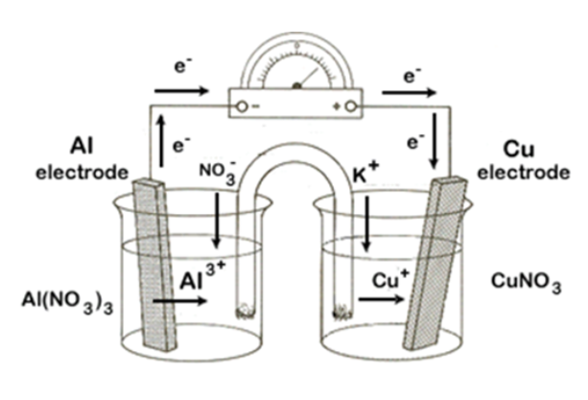
a) Identify the cathode.
b) What happens to the [NO₃⁻] in the Al half-cell as the cell is operating?

c) What happens to the [Cu⁺] in the copper half-cell as the cell is operating?

d) What is the role of K⁺ from the salt bridge?

e) Write the net redox reaction.

Assignment 10:
1. Draw an electrochemical cell with Mn and Pb electrodes and solutions of MnCl₂ and Pb(NO₃)₂ with a KNO₃ salt bridge.
a) Identify the anode.
b) Write the oxidation half-reaction.
c) Write the half-reaction occurring at the cathode.
d) Toward which electrode do the K⁺ ions in the salt bridge migrate?
e) Toward which electrode do the electrons travel in the wire?
f) What will happen to the mass of the Pb electrode?
2. Draw an electrochemical cell with one half-cell having an iron electrode and iron III nitrate solution and the other half-cell having an inert platinum electrode with Cl_{2(g)} being bubbled in. The electrolyte in that half-cell is aqueous sodium chloride. Use KNO₃ in the salt bridge.
a) Identify the cathode.
b) Write the half-reaction occurring in the iron half-cell.
c) What happens to the [NO₃⁻] in the iron half-cell?
d) Write the half-reaction occurring in the Cl₂ half-cell.
e) What happens to the extra Cl⁻ ions being produced at the cathode?
f) What is the function of the platinum electrode at the cathode?
g) Write the net redox reaction.
3. Read Hebden p.215-217 and do #34-35

XII) Standard Potentials
Cell potential, measured in volts (V), is the 'pull' on electrons. Potential, or voltage, acts on electrons just like ‘pressure’ acts on water, or like gravity acts on objects. In an electrochemical cell, the substance that wants to reduce pulls the electrons through the wire, and this movement of electrons is what is used to do work such as power a motor. One volt is defined as 1 joule of work per coulomb of charge transferred, so voltage gives an indication of how much work the electrochemical cell can do. The higher the voltage, the stronger the battery.
The magnitude of the voltage in an electrochemical cell depends on its half-reactions. If a substance that is very good at giving up electrons oxidizes (low on the right side of the table), and a substance that is very good at reducing gains the electrons (high on the left side), the cell will have a large voltage (large gap between half-reactions on table). The smaller the gap between the reduction and oxidation half-reactions, the smaller the voltage.

Find the cell voltage of a lithium/fluorine cell:
*When calculating cell voltage, switch the sign of the oxidation voltage:

*Coefficients don’t affect voltage, as it’s joule per coulomb of charge
The E° values on the table are at ‘standard state’, meaning 25°C, 1 atm pressure for gases (room pressure), 1M concentrations for all solutions. If any of these conditions are altered, the voltage is just an E value as it’s no longer at standard state.

Notice that each half-reaction is assigned a certain voltage on the redox table. It is impossible to set up just a half-cell (without another half-cell) and get a voltage reading. You can only get a voltage from a complete cell with oxidation and reduction half-reactions occurring simultaneously. So where do these values on the table come from?
The hydrogen half-cell at standard state was used as a reference half-cell, and arbitrarily assigned a voltage of 0.00V. 2H⁺ + 2e⁻ H₂ Eº = 0.00V

Every other half-cell was hooked up to the hydrogen half-cell and the voltage was recorded, and became the half-cell voltage for that respective half reaction.

Here is an example of the hydrogen half-cell and copper half-cell:

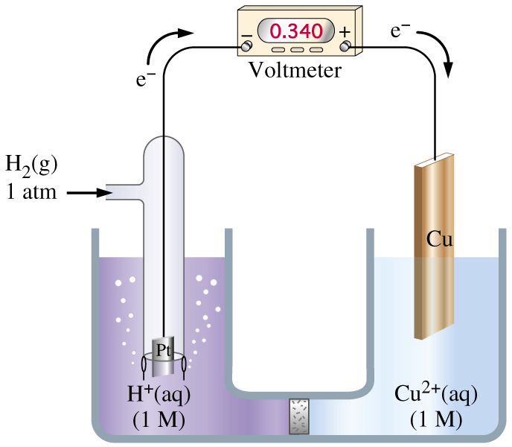
ANODE CATHODE
H₂ ⇒ 2H⁺ + 2e⁻ Cu²⁺ + 2e⁻ ⇒ Cu

What about a hydrogen half-cell with a zinc half-cell?
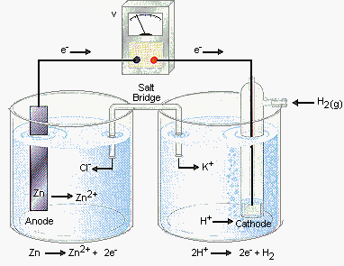
Any other half-reaction could have been chosen as the reference half-cell and been assigned 0.00V, but the hydrogen cell was used.

The voltages given on the table are for reduction half-reactions. To get oxidation half-reaction voltages, reverse the sign on the voltage.
Reduction of Cu²⁺: Cu²⁺ + 2e⁻ ⇒ Cu E° = 0.34V
Oxidation of Cu: Cu ⇒ Cu²⁺ + 2e⁻ E°= -0.34V

To predict the cell voltage of two half-cells, simply add the two half-reaction voltages together:
Example: Br_{2(l)} + 2e⁻ ⇒ 2Br⁻
Pb_{(s)} ⇒ Pb²⁺ + 2e⁻ _________
E°_{cell} =

A spontaneous reaction has a positive E°_{cell} and it’s an electrochemical cell.

A non-spontaneous reaction has a negative E°_{cell} or zero E°_{cell} and is an electrolytic cell (it won’t occur unless supplied with voltage).

Practice Questions
1. Calculate the standard potential of the cell: Cu²⁺ + Co ⇒ Cu + Co²⁺

2. Calculate the potential of the cell: 3Zn²⁺ + 2Al ⇒ 3Zn + 2Al³⁺
*Remember: Coefficients don’t affect the voltage

3. Write the complete redox equation and calculate the E°_{cell} of a Pb/Cr electrochemical cell.

Cells at Equilibrium
The E°_{cell} of a cell is the voltage at standard state, so solution concentrations are 1.0M. As the cell operates, reactants are being used up, so their concentrations are continually decreasing, thus the voltage of the cell starts to decrease. When all reactants are used up, the cell will cease to operate (the battery is dead), and the cell voltage will be zero. At this point, the cell is said to be at equilibrium.
Therefore, the voltage of a cell at equilibrium is 0 (a dead battery).

Assignment 11: 1) Hebden p.224-225 #36abcdef, 37, p.226 #46
(36f is a disproportionation reaction)

XIII) Cell Potential Practice Questions
1. Draw and label an electrochemical cell using a copper anode and having an E°_{cell} greater than 1.0V (The product of the oxidation is Cu²⁺).

2. If the E° for Ni²⁺ + 2e⁻ ⇒ Ni were set at zero volts, what would be the E° for Cu²⁺ + 2e⁻ ⇒ Cu ?

3. What will happen to an aluminum spoon if it is used to stir a solution of Fe(NO₃)₂ ? Use E° values to support your answer.

4. Four metals were used to set up the following electrochemical cells with their ions J²⁺, L⁺, K²⁺, and M³⁺:
Anode Cathode Cell Voltage
J L +0.30V
L K +1.60V
L M +1.30V

a) Identify the strongest reducing agent.

b) Identify the strongest oxidizing agent.

c) Calculate the voltage of a J/M cell.

5. Four half-cells are constructed by placing strips of the four metals W, X, Y, and Z in 1.00M solutions of their ions, W⁺, X²⁺, Y³⁺, and Z²⁺ respectively. Various combinations of these half-cells are connected, giving the following data:
Anode Cathode E°_{cell}
W X +0.20V
W Y +0.36V
Z W +0.14V

a) Which metal is the strongest reducing agent?

b) Which metal ion is the strongest oxidizing agent?

c) Write the balanced equation for the cell reaction that would occur when half-cells X and Y are connected.

d) Calculate the voltage produced when half-cells X and Y are connected to produce a spontaneous reaction.

6. Consider the following redox data:
3V²⁺ + 2Ga ⇒ 3V + 2Ga³⁺ E° = -0.64V
3V²⁺ + 2Al ⇒ 3V + 2Al³⁺ E° = +0.46V
Based on these observations, a student concludes that Ga³⁺ and Al will react spontaneously. Evaluate this conclusion and support your answer with calculations.

Assignment 12
1. An electrochemical cell has electrodes of Pb in Pb(NO₃)₂ and Cr in Cr(NO₃)₃. Calculate E°_{cell} .
2. Use the following diagram of a cell at 25°C to answer the questions:
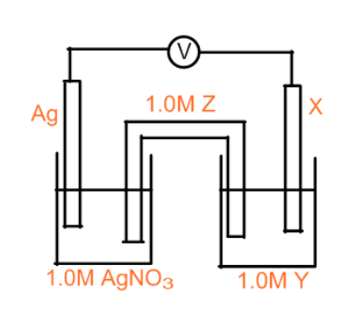

The electrochemical cell produces an initial voltage of 0.93 V.
a) Identify the metal "X"
b) Identify a suitable electrolyte "Y"
c) Identify a suitable electrolyte "Z"
d) Indicate, on the diagram the direction of electron flow.
3. Can Fe₂(SO₄)₃ be stored in a container made of nickel? Support with E° calculations.
4. Draw and label the parts of an operating electrochemical cell using a zinc anode that will produce an electric current having a voltage of 1.56V at standard conditions.

5. Consider the following electrochemical cell:
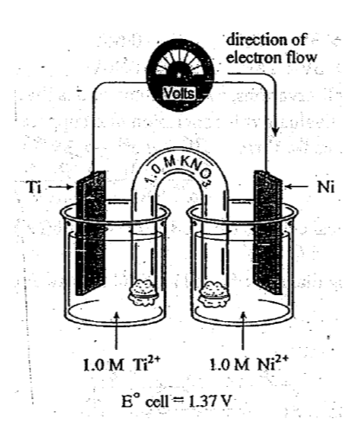

a) Write the equation for the half-reaction that occurs at the anode.
b) Calculate the reduction potential of Ti²⁺.

6. Given the following diagram of an electrochemical cell, which is constructed in order to determine the reduction potential of a Cadmium half-cell, answer the questions provided:
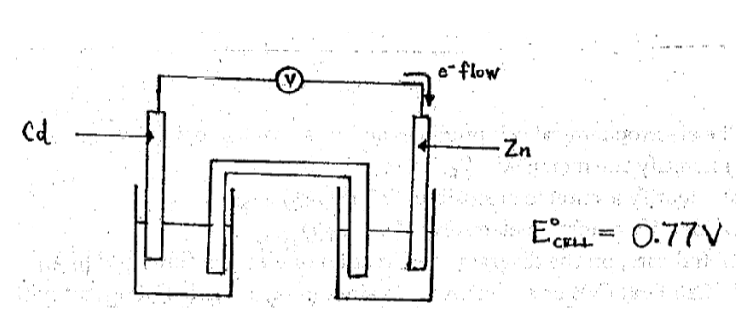
a) Identify the cathode in the cell.
b) Write the half-reaction occurring at the Cd electrode.
c) Determine the E° for the half-reaction: Cd²⁺ + 2e⁻ ⇒ Cd

7. Four metals were used to set up the following electrochemical cells.
Anode Cathode Cell Voltage
A B +1.402V
A C +1.230V
Z A +0.080V
a) Rank the metals from strongest reducing agent to weakest.
b) Predict the E° of a Z/B cell.
8. The following reactions occur at 25°C with all substances present in 1.0M concentrations.
Zn + Pb²⁺ ⇒ Zn²⁺ + Pb
Ti + Zn²⁺ ⇒ Ti²⁺ + Zn
2Lu + 3Ti²⁺ ⇒ 2Lu³⁺ + 3Ti
Predict whether each of the following reactions will occur:
a) Pb + Ti²⁺ ⇒ Pb²⁺ + Ti
b) 2Lu + 3Pb²⁺ ⇒ 2Lu³⁺ + 3Pb
c) 2Lu³⁺ + 3Zn ⇒ 3Zn²⁺ + 2Lu

9. The metals Rh, Ti, Cr, and Pd are individually placed in 1.0M solutions of Rh²⁺, Ti²⁺, Cr²⁺, and Pd²⁺ , and the cell voltages of the spontaneous reactions are determined.
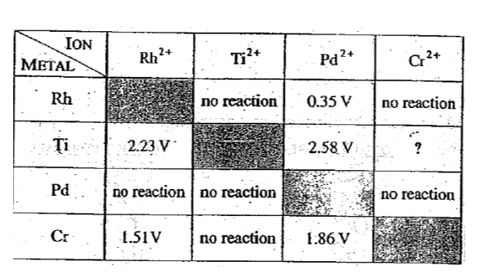
a) Arrange the metals in order of increasing strength as reducing agents.
b) Determine the cell voltage for Ti in a 1.0M solution of Cr²⁺ .
10. Hebden p. 225 #38, 40-41

XIV) Selecting Preferred Reactions
In many reaction environments, there’s more than one substance that can reduce, and/or more than one substance that can oxidize. How can you determine the reaction that actually occurs?
1. When several different reductions can occur,

2. When several different oxidations can occur,

Write the redox equation that will occur for the following cell:
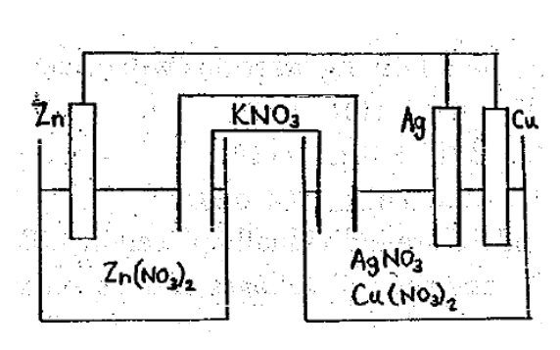
A method to deduce the actual reaction occurring:
i) List all possible oxidizing agents reducing agents

ii) Circle each agent that is the most preferred
iii) Write the overall reaction.

2. A beaker contains an iron nail wrapped with both a piece of copper wire and a piece of magnesium ribbon, immersed in a solution containing CuSO_{4(aq)} and some dissolved Cl_{2(g)}. What is the preferred redox reaction?

Assignment 13: Do Hebden p.228 #47
XV) Applied Electrochemistry
Breathalyzer
Police use a breathalyzer to test for alcohol consumption. The breathalyzer consists of a redox reaction that includes a colour change. The intensity of green colour produced is measured to find the amount of alcohol in the blood.
The colour change is due to the orange dichromate ion (Cr₂O₇²⁻) reacting to produce the green chromium ion (Cr³⁺) due to a reaction with ethanol, C₂H₅OH, the alcohol used in beverages.
C₂H₅OH + K₂Cr₂O₇ + H₂SO₄ ⇒ CH₃COOH + Cr₂(SO₄)₃ + K₂SO₄ + H₂O
ethanol orange green
All reactants are in the breathalyzer in excess, except the ethanol, which comes from one’s breath. The amount of Cr³⁺ produced is dependent on the amount of ethanol, therefore the colour change and intensity of green is dependent on the amount of ethanol provided.
How do you know the above equation is a redox equation?

Batteries
For any battery, electrons produced at the anode leave the battery to power a device and return via the electrical circuit to the cathode for reduction.
Zinc-Carbon Battery (aka Dry-Cell ‘Dry’ because ions in a paste)

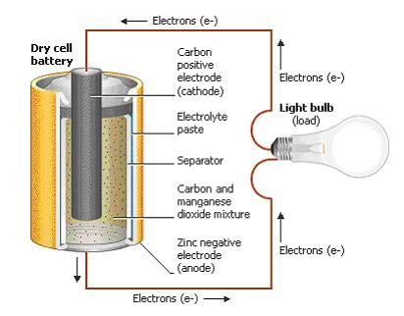
oxidation half-reaction: Zn ⇒ Zn²⁺ + 2e⁻ *the Zn casing acts as the anode
reduction half-reaction: 2MnO₂ + 2NH₄⁺ + 2e⁻ ⇒ Μn₂O₃ + 2NH₃ + H₂O
The Zn casing around the battery is the anode. A carbon rod down the centre is the inert cathode. The battery dies when all of the Zn is consumed.

Advantages: cheap materials
Disadvantages: not rechargeable, short shelf life, voltage inconsistent

Alkaline Dry Cell (Modified Version of Zinc/Carbon Dry Cell)
Same as the zinc-carbon battery except the paste is manganese dioxide and potassium hydroxide.
The KOH electrolyte gives this battery its name (alkaline = basic). The half-reactions are the same as the zinc-carbon battery except they are under basic conditions. Alkaline batteries are the most common battery today.
Anode half-reaction: Zn + 2OH⁻ ⇒ ZnO + H₂O + 2e⁻
Cathode Half-Reaction: 2MnO₂ + H₂O + 2e⁻ ⇒ Mn₂O₃ + 2OH⁻

Advantages: - more efficient ion transport in basic (alkaline) electrolyte
- more constant voltage than zinc/carbon battery
Disadvantages: - materials more expensive

Lead-Acid Storage Battery (Car Battery)
This is the type of battery found in automobiles. It is made up of 6 individual cells connected in series, with each cell producing 2 volts (making a 12 volt battery). Each cell consists of one Pb plate and one PbO₂ plate immersed in Sulfuric Acid. The cathode and anode do not need separate compartments since both Pb and PbO₂ are solids, thus they cannot come in direct contact. This battery primarily serves to start the car.
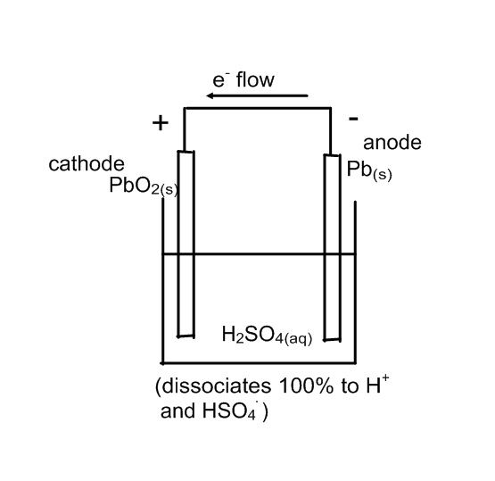

Discharging half-reactions:
Anode: Pb_{(s)} + HSO₄⁻ ⇒ PbSO_{4(s)} + H⁺ + 2e⁻
Cathode: PbO_{2(s)} + 3H⁺ + HSO₄⁻ + 2e⁻ ⇒ PbSO_{4(s)} + 2H₂O
*Recharging half-reactions would be the reverse of the discharging rxns
Notice that solid PbSO₄ is a product of each half-reaction. It sticks to both electrodes and serves as the reactant when the battery is recharged, which is accomplished by applying a voltage to reverse the half-reactions. The alternator does this; it is powered by the motor to convert its mechanical energy to chemical energy, which then provides the necessary voltage to the non-spontaneous recharging reaction. Eventually, PbSO₄ can ‘flake-off’ of the electrodes, due to bumps, erratic driving etc, and fall to the bottom of the H₂SO₄ bath. This loss of reactants disallows the battery from fully recharging. Eventually, a new battery is required.

Fuel Cell
Fuel cells are different from the batteries described above because fuel cells have to be continually supplied with hydrogen and oxygen gas whereas the other batteries are self-contained units.
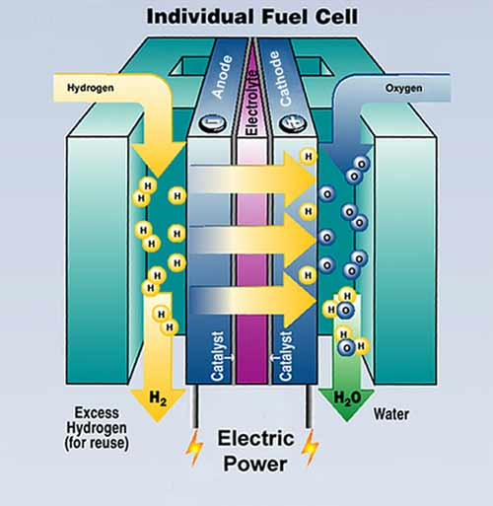

Anode Half-Reaction: 2H₂ ⇒ 4H⁺ + 4e⁻
Cathode Half-Reaction: O₂ + 4H⁺ + 4e⁻ ⇒ 2H₂O
Overall Reaction:

Advantages: non-polluting, produces drinkable water, efficient
Disadvantages: expensive, require a lot of maintenance,
dangerous due to compressed gases

Assignment 14: Read Hebden p. 228-233 Do #52, 53, 55a, 56

XVI) Corrosion of Iron
What must be present in order for iron to rust?

Iron corroding is actually a redox reaction. What do you think happens to the Fe metal?

Where do the resulting electrons go?

So what serves as the anode? The cathode?

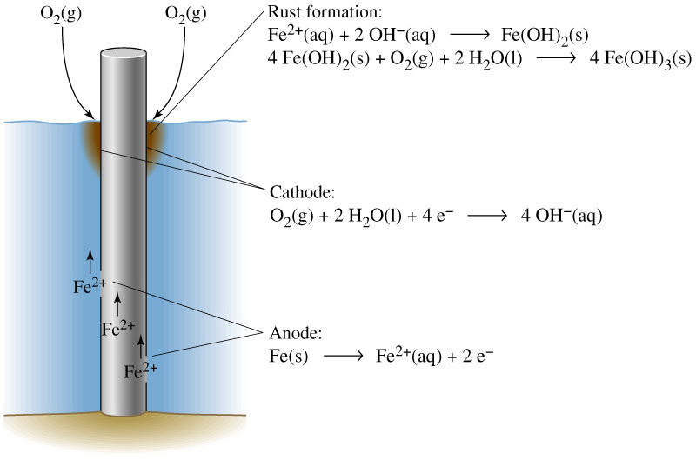

Anode Half-Reaction: Fe ⇒ Fe²⁺ + 2e⁻
Cathode Half-Reaction: O₂ + 2H₂O + 4e⁻ ⇒ 4OH⁻

The Fe²⁺ created at the anode follows the electrons to the cathode and dissolve in the water present. This helps maintain neutrality as the negatively charged OH⁻ is produced at the cathode. In fact, Fe²⁺ combines with the hydroxide ion, producing solid iron (II) hydroxide.
Fe²⁺ + 2OH⁻ ⇒ Fe(OH)₂
The iron (II) hydroxide then reacts with oxygen and water to make Fe(OH)₃. Then Fe(OH)₃ decomposes to FeO(OH) + H₂O, and then two FeO(OH) molecules collide to make Fe₂O₃ + H₂O. Rust is actually Fe₂O₃ as well as its hydrated form, Fe₂O₃•xH₂O. This accounts for the different colours in rust.
Corrosion cannot occur in dry air or in oxygen depleted water (deep water). Why?

Protection from Corrosion
There are two protection types: Physical and Electrochemical
Physical Protection
What does physical protection from corrosion mean?

What are some different types of physical protection?

Electrochemical Protection
What does electrochemical protection from corrosion mean?

There are two types of electrochemical protection:
1. Cathodic Protection
Why do people put zinc strips on the iron hull of boats?
Zinc oxidizes more readily than iron (check your table). Therefore, if zinc is available, it will oxidize to Zn²⁺ before any Fe will oxidize. Attaching zinc strips to iron will prevent iron from rusting as the zinc will oxidize first, and the electrons from the zinc will conduct through the iron to the site of reduction (where the water and oxygen is). The zinc is called a sacrificial anode (it sacrifices itself for the iron). Zinc provides Fe with electrons and Fe acts as the cathode to conduct electrons to O₂ and H₂O. The the zinc does not have to completely cover the Fe.
Anode Half-Reaction: Zn ⇒ Zn²⁺ + 2e⁻
Cathode Half-Reaction: O₂ + 2H₂O + 4e⁻ ⇒ 4OH⁻
The oxidation of the Zn will decrease its mass. Regularly replacing the sacrificial anode (Zn strips) will ensure that the Fe will not corrode.

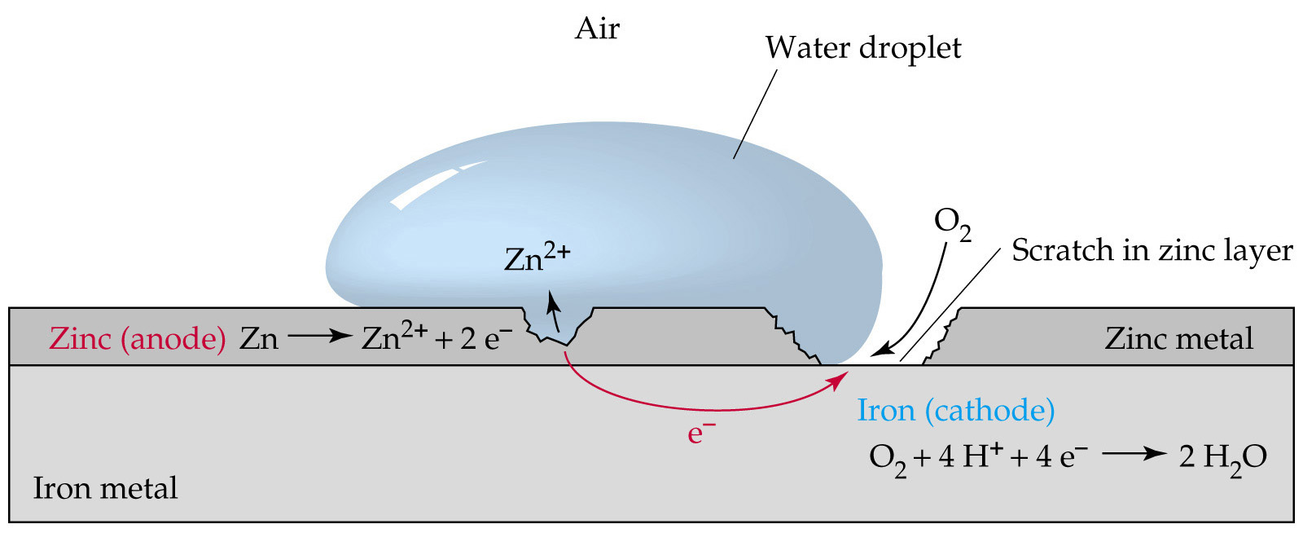

2. Supplying an electric current to the iron
Some ships will supply a low voltage electric current (a stream of electrons) to the iron hull. This prevents the iron hull from having to oxidize to supply electrons to oxygen and water, thereby preventing corrosion.

Assignment 15: Corrosion Exercises
1. Can Zn be used as a sacrificial anode for Al? Explain.
2. Would it be smart to use a tin based paint on the bottom of an aluminum boat? Why or why not?
3. The Statue of Liberty consists of an iron frame covered with copper. Discuss the reasons for the rapid corrosion in this structure.
4. Why hasn't the Titanic corroded?
5. To prevent an environmental disaster, how could you stop an underground iron septic tank from rusting through without actually having to dig it up?
6. Why does most car rust start in or around the wheel wells?

XVII) Electrolysis
Recall that a spontaneous cell (a _____________) is called an __________________________ cell.
What is an electrolytic cell?

How does an electrolytic cell function?

What is electrolysis?

Why don’t electrolytic cells need separate half-cells?

There are two types of electrolytic cells.
1) Molten Electrolytic Cell- Electrolysis of a Molten (Liquid) Salt
A molten salt is a salt that has been melted into liquid form, so no water is present in the cell. This takes very high temperatures and is expensive.
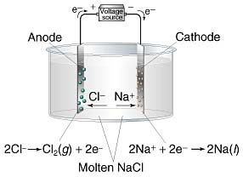
The only substances in the cell available to react are Na⁺ and Cl⁻. The electrodes are inert, meaning they are unreactive.
The inert cathode electrode becomes negatively charged as the battery pumps electrons to it. The negative charge draws Na⁺ ions to the cathode to be reduced.
The inert anode electrode becomes positively charged because the battery pulls electrons away from it. The positive charge draws Cl⁻ ions to the anode to be oxidized.
Cathode Half-Reaction: Na⁺ + e⁻ ⇒ Na E°_{reduction} = V
Anode Half-Reaction: 2Cl⁻ ⇒ Cl₂ + 2e⁻ E°_{oxidation} = V
Overall Reaction: E°_{cell} = V

Slightly more than ______V would have to be supplied by the battery in order to make this cell function.

Notice on the molten cell that the positive side of the battery (the cathode) is always connected to the anode of the electrolytic cell. The negative side of the battery (the anode) is always connected to the cathode of the electrolytic cell.
Sometimes, when solving a problem, this is the only hint you’re given in order to determine the anode and cathode of the electrolytic cell.

2) Aqueous Electrolytic Cell - Electrolysis of an Aqueous Salt (a salt solution)
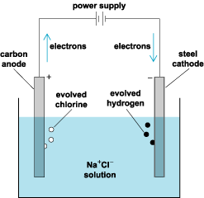
For an aqueous electrolytic cell, water is present with the salt ions, so it could oxidize or reduce in place of the ions (depends on half-reactions on the table). Use the table to determine the half-reactions.
Potential O.A. Potential R.A.

Cathode Half-Reaction: Voltage =
Anode Half-Reaction: Voltage =

Overall Reaction: E°_{cell} =

The battery must provide a voltage of slightly more than __________V.
What colour would the solution be if phenolphthalein was added? Why?

Practice Questions:
1. Draw a diagram for, find the half-reactions, overall reaction, and voltage necessary to run an MgCl_{2(l)} cell.

a) Is this cell molten or aqueous?

b) Which side is the anode?
c) What are the anode and cathode composed of?
d) Which substances are competing to reduce?
To oxidize?
e) What is the ‘overpotential effect’?

f) Write the half-reactions and overall reaction (with voltages).

g) What observations could you make for the cathode?
2. Consider the following cell:

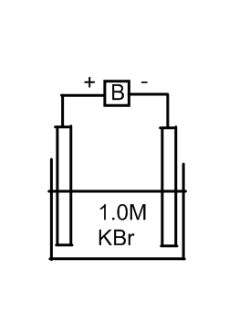

3. Draw an electrolytic cell capable of electrolyzing water (water is oxidized and reduced) to make H₂ and O₂. Ions must be present in the cell (to maintain cell neutrality at each electrode), so a salt must be part of the cell. Give the half-reactions and the overall reaction (including voltages).

Assignment 16: Do Hebden p.238 #64ab & p.242 #65abc, 67, 69, 71

Electroplating
Electroplating is an electrolytic process where a metal is plated onto another metal for protection or decoration.

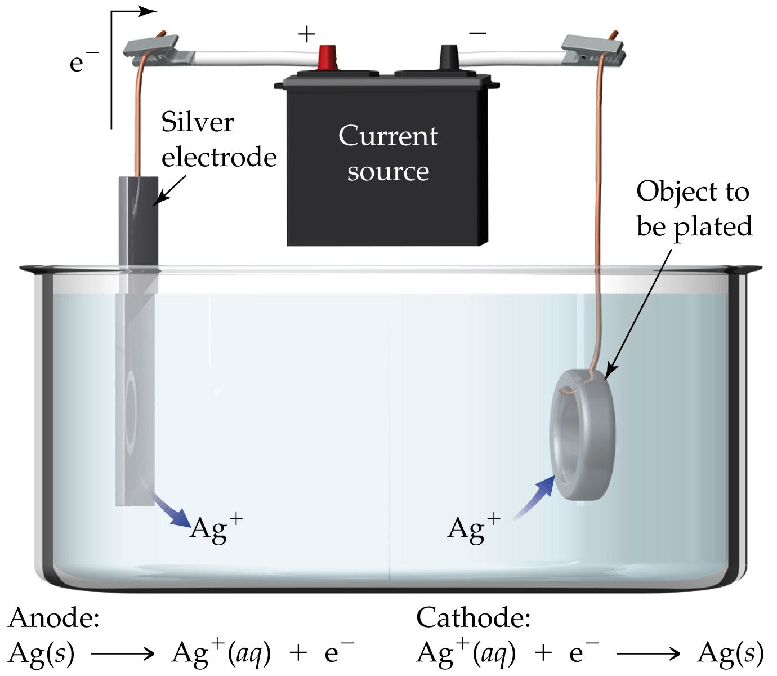

The metal that will be used for plating is first oxidized at the anode (from metal to ion). It then travels across the electrolyte as a cation (it’s attracted to the electrons waiting at the cathode) and is reduced at the cathode (from ion back to metal).

What is the overall reaction of the electroplating cell above?

What is the point of electroplating if there is no overall reaction?

For an electroplating cell, what is the anode and what is the cathode?

What should the electrolyte be composed of?

What voltage must be supplied by the battery in order for the electroplating to occur?

Design an electrolytic cell which will result in a nickel coin being plated with copper. Label the anode, cathode, and electrolyte. Give the half-reactions, the overall reaction, the voltage, and the voltage required for the process to occur.

Design an electrolytic cell which could be used to electroplate an iron hood ornament with chromium. Draw the cell and label all parts. Show the direction of electron flow in wire. Write the half-reactions and identify a suitable electrolyte.

Electrorefining
An electrolytic process where impure metal ore becomes pure metal. Below is an example of electrorefining copper.
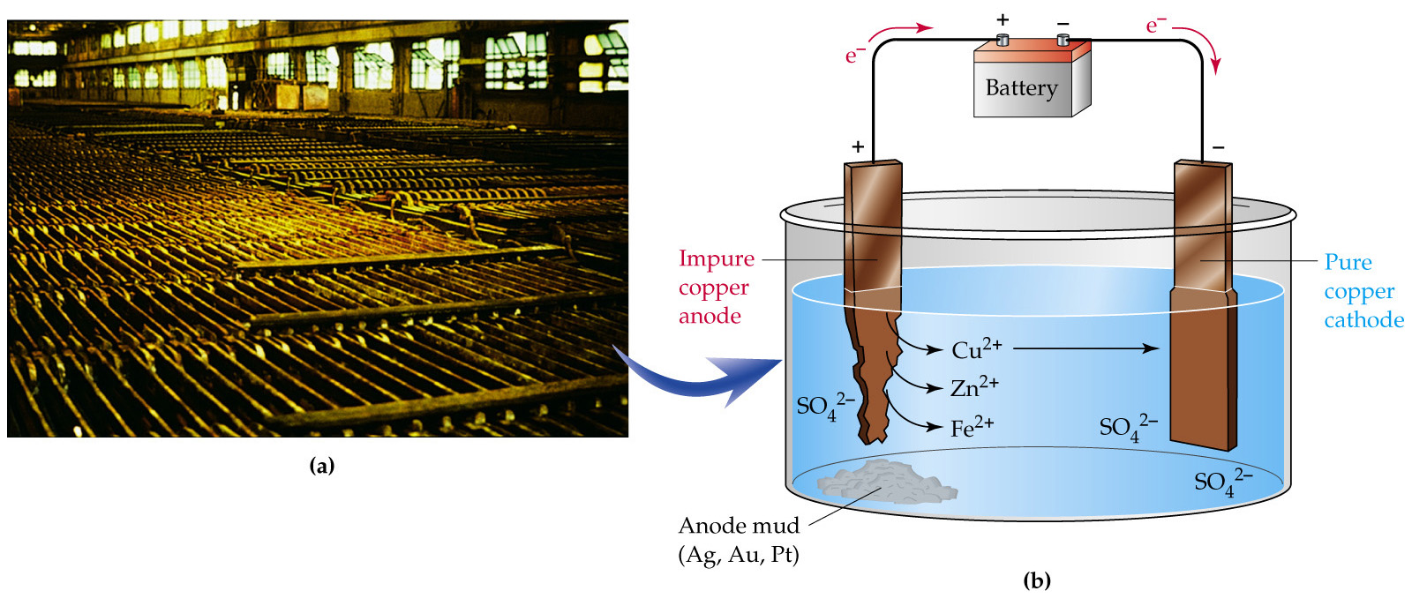

The impure copper ore anode contains various amounts of zinc, iron, silver, platinum, and gold, but mostly copper. What order will these metals oxidize?

Because copper will always be on the surface of the anode (since the anode is mostly copper), silver, platinum, and gold will never get a chance to oxidize and will fall to the bottom of the cell making the ‘anode mud’. Therefore, when zinc is on the surface of the ore, it will oxidize. When it isn’t, Fe will oxidize. And when neither is on the surface, copper will oxidize.
Therefore, what three cations will exist in the solution?
What ion out of the three listed is best at reducing?

Therefore, why will Cu²⁺ be the only ion to reduce onto the pure Cu cathode?

Once all of the copper is reduced, the cell is terminated. The electrolyte is CuSO_{4(aq)}, in order to have extra Cu²⁺ ions in solution.

Assignment 17:
1) Do Hebden p.244 #73,75,76
2) Read p.245-246 and do #77

